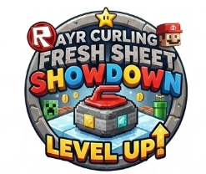 | 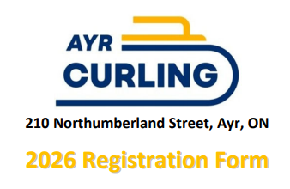
Please send completed registration forms to:
cassandra.struke@gmail.com
Team Name
Home Curling Club
Player and Experience (Circle One) | 1. | [ ] Beginner [ ] Intermediate [ ] Advanced
Player and Experience (Circle One) | 2. | [ ] Beginner [ ] Intermediate [ ] Advanced
Player and Experience (Circle One) | 3. | [ ] Beginner [ ] Intermediate [ ] Advanced
Player and Experience (Circle One) | 4. | [ ] Beginner [ ] Intermediate [ ] Advanced
Team Contact | Name:  E-mail:  Cell #:
Age Category  (Check One) | [ ] U12 [ ] U15  *U12: 12 & under as of Dec 31, 2026. First draw = 11:15am  *U15: 15 & under as of Dec 31, 2026. First draw = 9:00am
Dietary Restrictions
(if any)
Please send entry fees to: ayrhitandroll@gmail.com
[Please include the Team Name and 'Junior Bonspiel' in the message field]

